

EE 463

STATIC POWER CONVERSION I

HARDWARE PROJECT FINAL REPORT

Orhun TAŞOĞLU 2094506

Mert ZEYBEK 2167682

Kutay DELİBAŞ 2093599

Submission Date: 15.01.2019

Table of Contents

1. Introduction 2

2. Design Choices 2

2.1. Topology Selection 3

2.2. PWM Generation 3

2.3. Optocoupler & Gate Driver 4

2.4. Semiconductor Components Selection 5

2.5. Other Components Selection 6

2.6. Thermal Design & Heatsink Selection 7

3. Simulation Results 9

4. Test Results 12

5. Cost Analysis 15

6. Challenges 16

7. Conclusion 18

# Introduction

Controllable AC-DC converters are used commonly in our daily life and they are are one of the main topics of power electronics field. They allow us to transfer power from AC side-generally the grid- to another with desired amplitudes so that we can power our systems. Desired qualities of these converters are high efficiency, high power density, low cost and reliable output. There should be a balance between those factors, and without proper designing before implementation, it can not be known how the system will perform regarding the mentioned properties. Therefore, a detailed designing phase is carried out.

In this project, an AC-DC converter is designed and implemented and tested on a large industrial DC motor to drive a generator. For the design, certain choices such as topology selection and control method were made in order to keep it simple and effective, which will be explained in this report. Following the choice, simulation of the design is done with Simulink. Afterwards, implementation and testing of the project began. As this process advanced, design was also slightly altered and improved in order to keep the implementation realistic and successful. Thermal design was also considered, which affected choice of components as well as layout of the implementation. Finally, the converter was DC motor -loaded and unloaded- to prove the design works and can transfer power efficiently. These test results also the challenges faced during the process is also provided in this report.

# Design Choices

After the simulation report is submitted and our suggested system topology is verified, some parts of the system needed to be designed in detail. PWM Generator, Optical Isolator & Gate Driver needed to be implemented to replace the PWM block in the simulation. Since we worked with real circuit elements, there were more elements which were not in the simulations but should be taken into consideration. Heat dissipation of semiconductors, stray inductances, placement of the components and ensuring proper connections were critical for proper and robust operation. Block by block, details about design choices are given in this section.

## Topology Selection

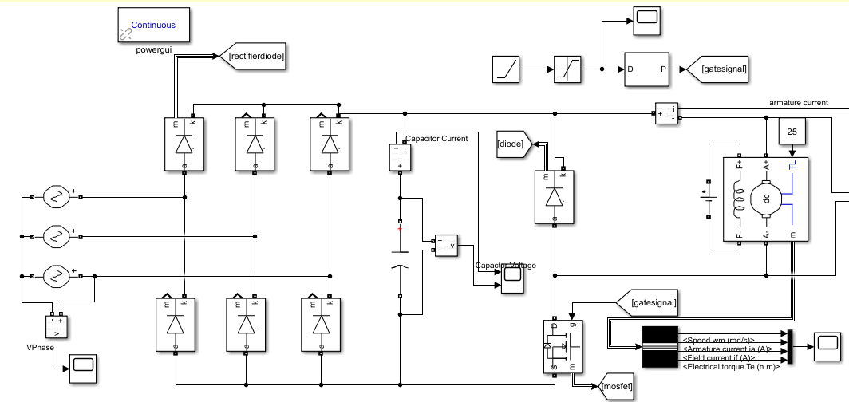

Figure 1 Overall Circuit Diagram of AC to DC Motor Drive

3-Phase Rectifier and Buck Converter topology with low side switching is used as it was proposed in the Simulation Reports, which is given in Figure 1. As expected, the motor provided enough filtering and it was proven that LC filter was not needed in our case. Making this decision saved us both time and money, since finding a suitable inductor in the market that is ready to purchase would be more or less impossible and it needed to hand wound. In other words, buying more components and spending extra time.

Implementing low-side switching eliminated the need for isolated supply, however an optocoupler is used in case. Moreover, it helped us eliminate the need for a second power supply. As a result, our design became less complex, using only one DC supply.

## PWM Generation

To generate PWM signal with adjustable duty cycle, TL494 IC is used. It is chosen since the chip is widely available (also in the laboratory), it is analog so does not require software programming and implementation is easy & understandable. A potentiometer is used to change the duty cycle which is actually a basic voltage divider. Difference between the potentiometer output and reference signal is used to calculate desired duty cycle by the IC. The circuitry is given is Figure 2.

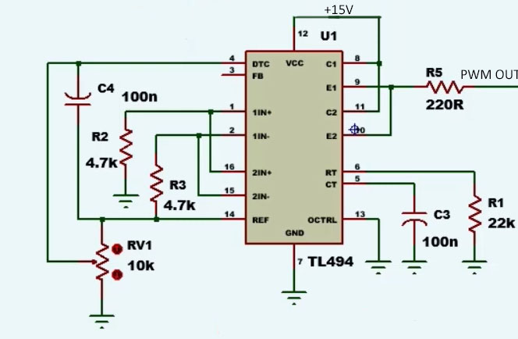

Figure 2 Adjustable Duty Cycle PWM Generator Circuit

However, using this circuit to directly drive the IGBT would be impossible since TL494 cannot supply the desired current to turn on the transistor. Therefore, additional circuitry was needed.

## Optocoupler & Gate Driver

A gate driver was needed to be able to use the generated PWM as the gate signal as mentioned. Also, to isolate the sensitive low voltage components from the high voltage paths where also high currents pass, using a optocoupler is a good security measure to prevent the components getting harmed in case of a failure.

An analog amplifier could have been used for gate signal part, but since TLP250 IC can handle both of our requirements, the IC is used, in the circuit given in Figure 3.

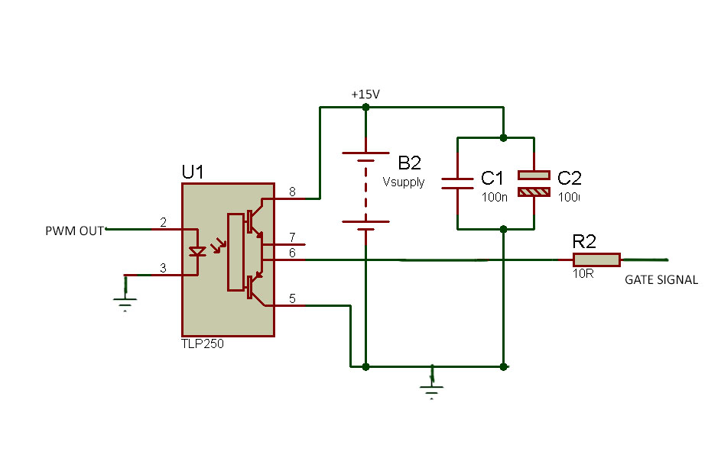

Figure 3 Optocoupler Circuit

## Semiconductor Components Selection

While choosing semiconductor elements, our main aim was finding the optimum spot considering the trade-off between cost, efficiency and robust operation. In order to select proper semiconductors, voltage and current stresses were acquired in Simulation Report are used. Selecting components with much higher ratings than stress values would assure proper operation of the system, but it would increase cost, which is obviously not desired. Selecting components whose ratings are too close to stress would risk the circuit’s operation. Inrush currents at the starting of the operation, parasitic effects such as ESR values, cable inductances may change stress values that would cause failure of semiconductor devices. As a result, cost could have still increased since it would be necessary to replace them.

First semiconductor component that was considered is bridge rectifying diode. Although our initial design was using 6 single diodes for this stage considering cooling, we changed it to bridge diode. Considering bridge diode’s thermal ratings we decided that it would not cause any problem in terms of thermal design. It is also easier to solder bridge diode, which is another advantage.

For bridge diode, 36MT160, which has ratings of 1600 V off-voltage and 35 A load current is used. Its photo is given in Figure 4. In simulations, we observed -160 V on bridge rectifier which was way below than our component’s voltage rating. Current was the limiting stress on this case. We observed 40 A average on simulations. This value was higher than the actual value due to spikes in simulation, which were not present in real applications due to cable’s inductance.

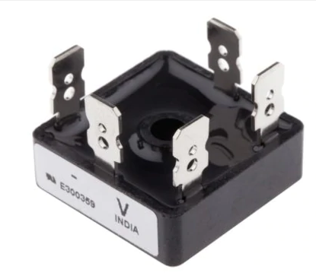

Figure 4 36MT160 Diode Rectifier

Another diode that we used was freewheeling diode. In simulation results, stress on freewheeling diode was measured as 25 A and 160 V. DHG30I600PA is used, whose ratings are 30 A and 600 V. One main advantage of this diode is its fast-recovery feature. It managed to fully turn-on and turn-off with 1.3 kHz frequency. Since our operating frequency was not too high, we did not need to use ultra-fast recovery diode.

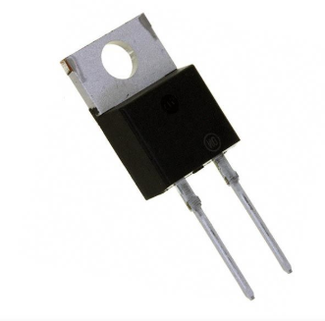

Figure 5 DHG30I600PA Diode

Final semiconductor that we used was transistor. Between MOSFET and IGBT, we decided to use an IGBT transistor since our operating frequency is not too high but we wanted to supply 2 kW power while supplying power to kettle. IGBTs also have lower on-resistances which is desired since we wanted to achieve higher efficiency. As a result, IGBT was more suitable for our operation. According to simulation results, VDS value was 160 V and IDS was 25 A. IXGH24N60C4D1 IGBT was selected, whose ratings are 600 V and 30 A, which are suitable to provide a robust performance.

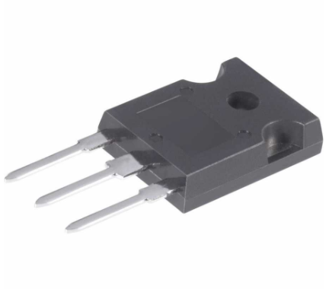

Figure 6 IXGH24N60C4D1 IGBT

## Other Components Selection

In capacitor selection, we wanted to minimize ripple voltage, so that input of buck converter would be close to ideal DC. In order to achieve that, we wanted to select a capacitor with high capacitance to keep voltage changes at minimum. On the other hand, increasing capacitance too much would increase price and volume significantly. We paid attention to voltage rating of capacitor. Simulation results gave us 160 V on the capacitor. We chose a capacitor with 400 V rating, which can handle higher voltages that might occur at some instants. We also paid attention to select a capacitor with smaller ESR, in order to keep efficiency high and decrease ripple among capacitors with desired ratings. As a result, an electrolytic capacitor is chosen.

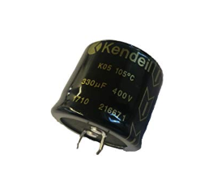

Figure 7 DC-Link Capacitor

Lastly, we needed to select a circuit board on which we will implement our project. Choosing breadboard would cause in failure since breadboards cannot handle high currents. This was not a problem for PWM circuit, but we wanted to implement the whole project on the same board for minimizing the volume. In addition, using solder rather than just placing PWM circuit elements on breadboard. Another option was implementing the circuit on PCB. This would require PCB design due to high currents that causes excessive heating. It could have been problematic due to our inexperience in PCB design. Another problem with PCB is debugging. It is not possible to make any changes in the circuitry if we want to make a change. As a result, we decided on implementing on stripboard since it offers both robust design and debugging. Photo of the stripboard that we used is given below.

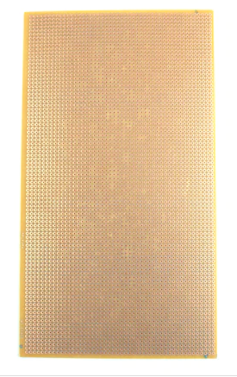

Figure 8 Stripboard

## Thermal Design & Heatsink Selection

Thermal design of the project was done using Lumped Parameter Model. Since most heat dissipation is done on the switching IGBT, the heatsink choice for that was done using this model. Required heatsink thermal resistivity was found using the following formula

Rheatsink= (Tj -Tamb)/P - Rth-jc (1)

Where

Tj : junction temperature

Tamb: ambient temperature

P : heat dissipated from the heat source

Rth-jc : junction to case thermal resistance

These values were read/calculated from datasheets of the components.

For IGBT:

Tj max= 175 C => choose Tj =150 C

Tamb= 25C

Rth-jc= 0.80 C/W

P= f. Ets = 1360 Hz . 1.46 mJ = 1.98 W

Rheatsink= 62.33 C/W

For IGBT, aluminum heat sink with dimensions 11.50x30.00x29.00mm was selected that offers

8.41 °C/W in natural convection setting, which is enough for the design. A similar separate heatsink was selected for freewheeling diode, which is also enough since it dissipates considerably less energy. The heatsinks can be seen in Figure X below.

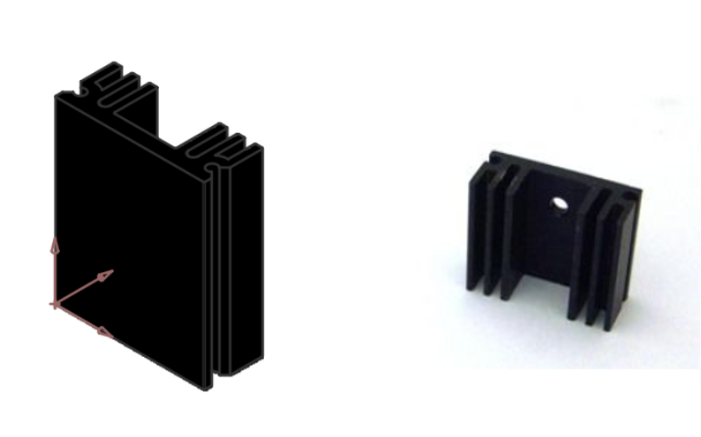

Figure 9 Heatsinks that are used for IGBT(left) and FWD (right)

# Simulation Results

After deciding on our circuit topology, we started to create a model for simulation, which is given in Figure 1. We tested our design under different circumstances such as different duty cycle values and recorded the stresses on components according to simulation results. This results later became helpful while we were selecting the components for implementation of the project.

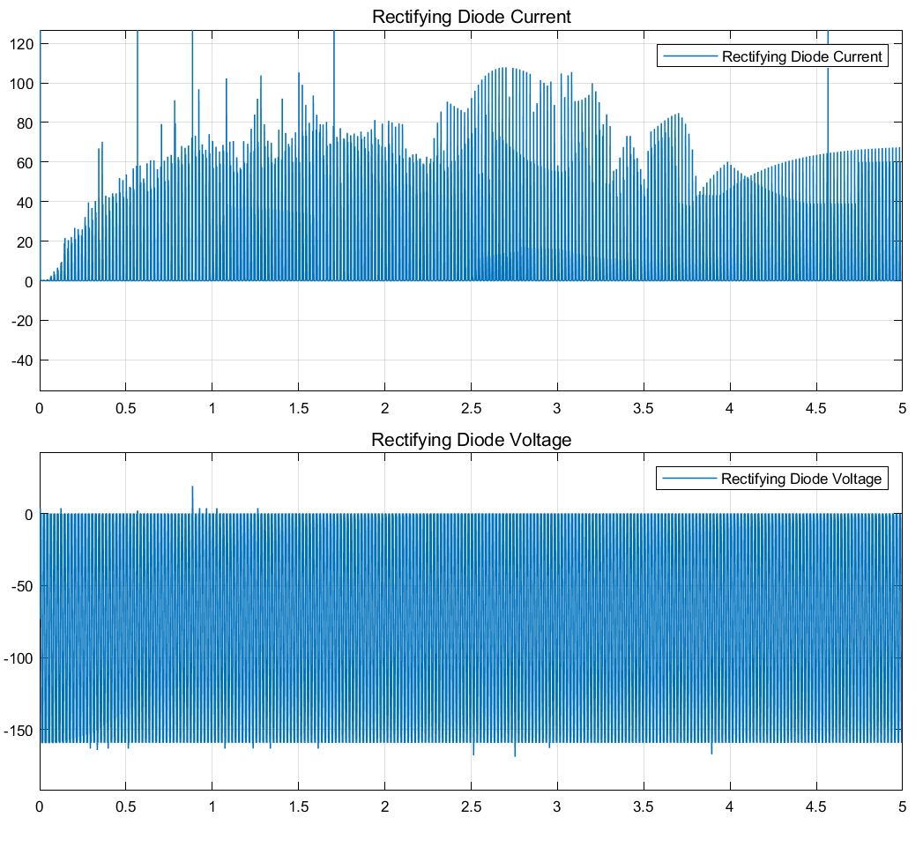

Figure 10 Graph of Rectifying Diode Current and Voltage for Duty Cycle slowly increased to 0.9



Figure 11 Graph of Rectifying Diode Current and Voltage for Duty Cycle slowly increased to 0.9

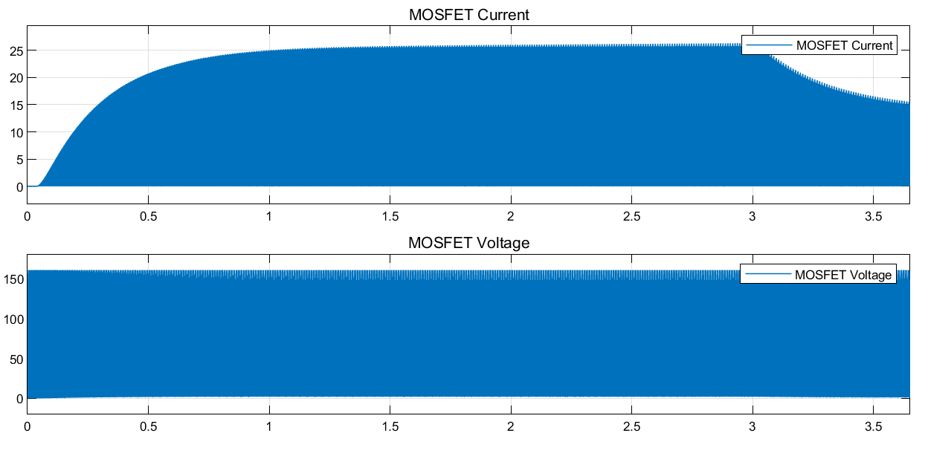

Figure 12 Graph of Transistor Current and Voltage for Duty Cycle slowly increased to 0.9

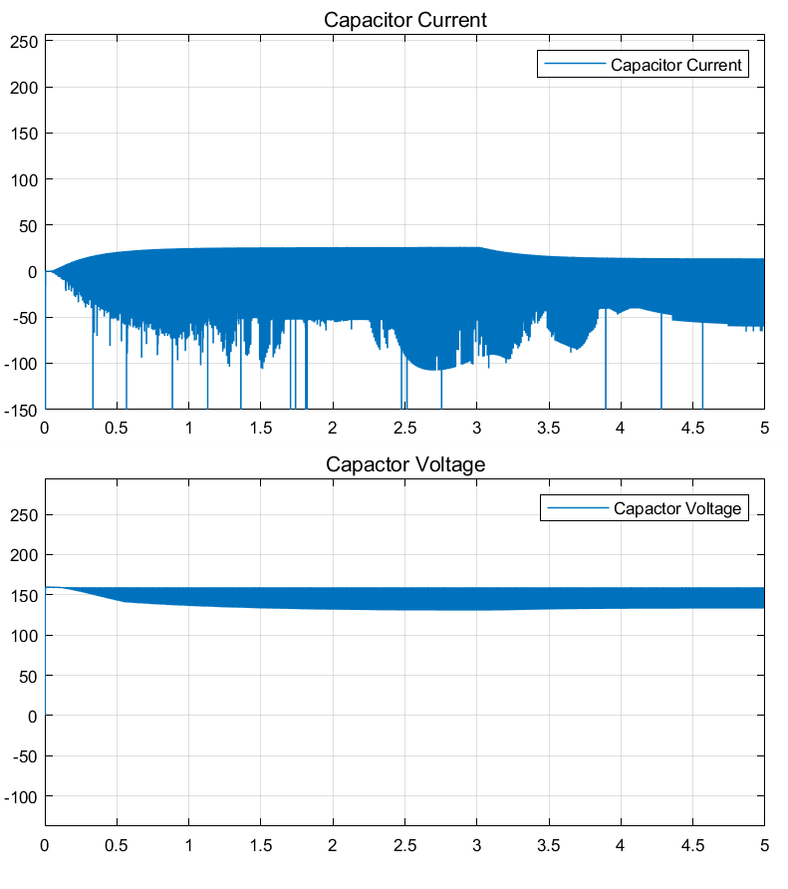

Figure 13 Graph of Capacitor Current and Voltage for Duty Cycle slowly increased to 0.9

Note that, there were spikes in capacitor current graph which could be misleading in component selection. They were not observed in the real case since inductance of the cable limits current change.

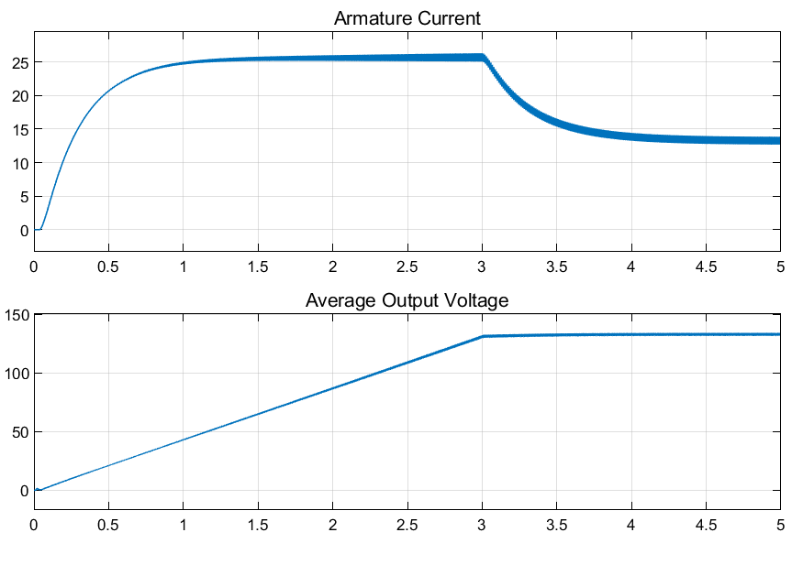

Figure 14 Graph of Output Voltage and Currents for Duty Cycle slowly increased to 0.9

# Test Results

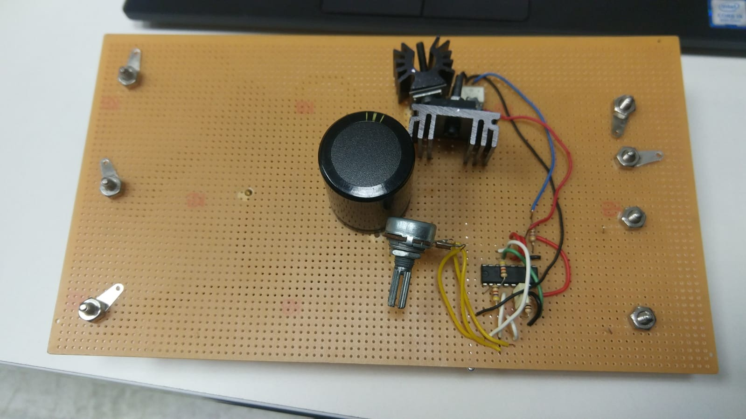

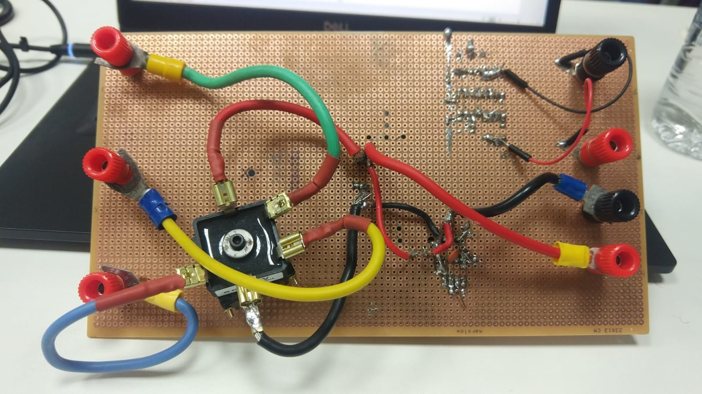

Figure 15 Implemented Circuit of the Project

The results are taken on project demonstration day, using the implemented circuit given in . First, DC motor was run connected to generator with no load. Then, a kettle was connected to generator such that it can absorb power from input, resulting in high current flow to the motor, which was more demanding on the circuit since heating can damage components, cables and soldering connections. For soft starting, variac was first adjusted for highest rated output voltage of 180V. Otherwise, voltage control was done with changing variac output and duty cycle. Various measurement results are given in Table 1.

Table 1: DC Motor Drive Test Results

|  |  |  |  |  |  |  |
| --- | --- | --- | --- | --- | --- | --- |
| Condition | Average Output Voltage(V) | Duty Cycle(%) | Average Output Current(A) | Output Power(W) | Input Power(W) | Efficiency(%) |
| No Load | 88.0 | 40 | 1.53 | 167 | 185 | 90.2 |
| 180.6 | 90 | 2.20 | 410 | 449 | 91.1 |
| Kettle Load | 189.3 | 90 | 9.96 | 1896 | 1980 | 95.7 |
| 195.7 | 90 | 10.24 | 2019 | 2090 | 96.6 |

Voltage control up to 180V was successfully done. Also, kettle load was connected for 5 minutes to boil the water inside. The test results show that as the output power increases, efficiency is also increasing because losses in the converter doesn’t change too much depending on output power. These readings are taken from pictures of power supply and oscilloscope screens, which are given below in Figure 15 through 18. Thermal camera reading for 180v no load case is given in Figure 20.

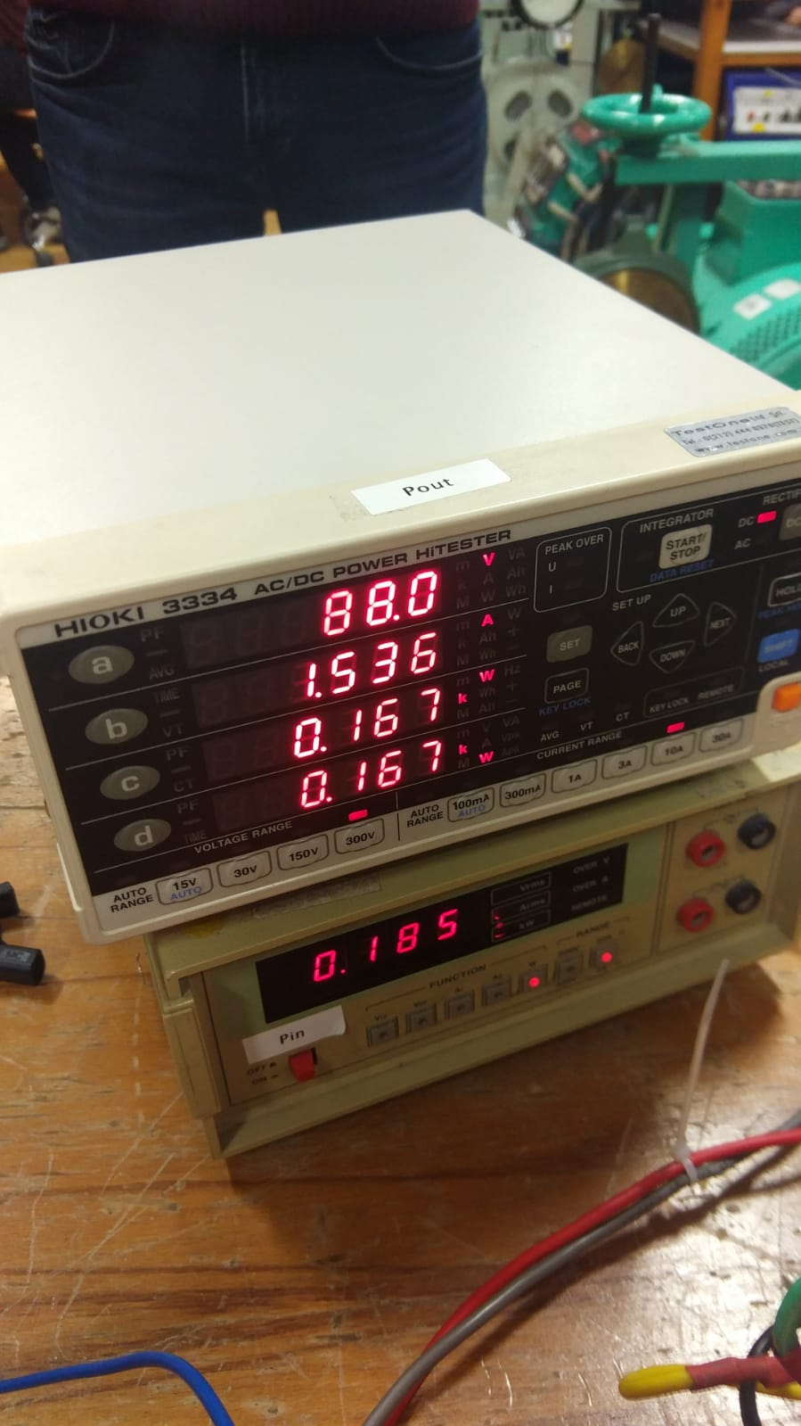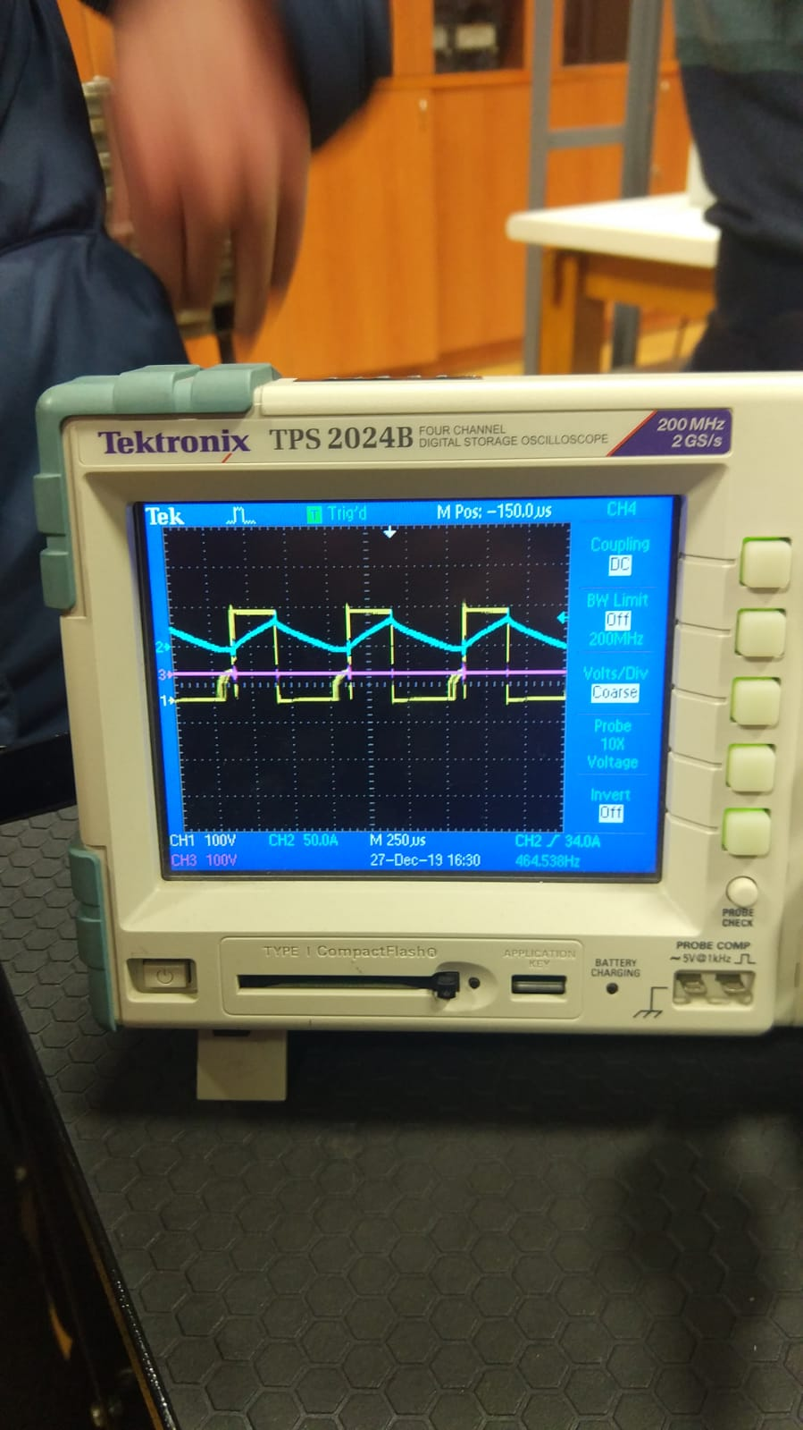

Figure 16 No load test with duty cycle=40% and output voltage=88V

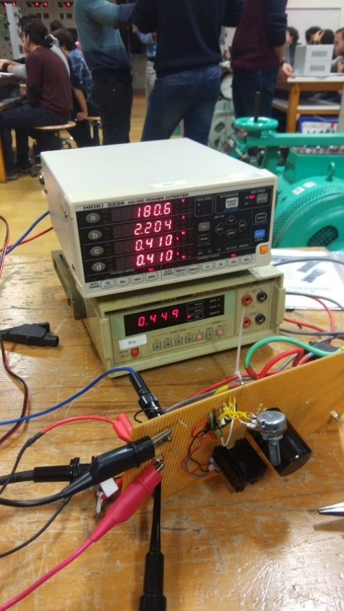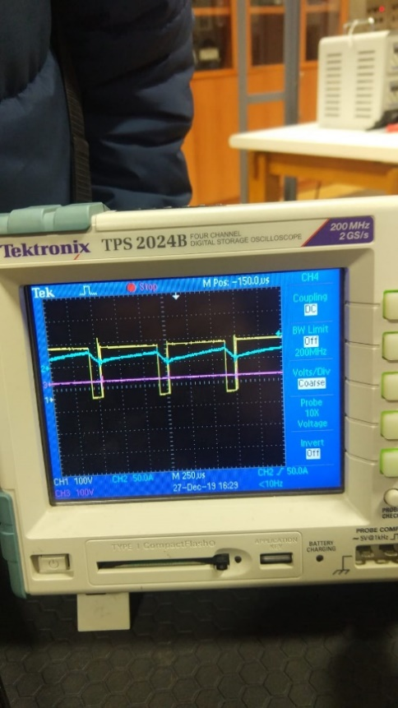

Figure 17 No load test with duty cycle=90% and output voltage=180.6V

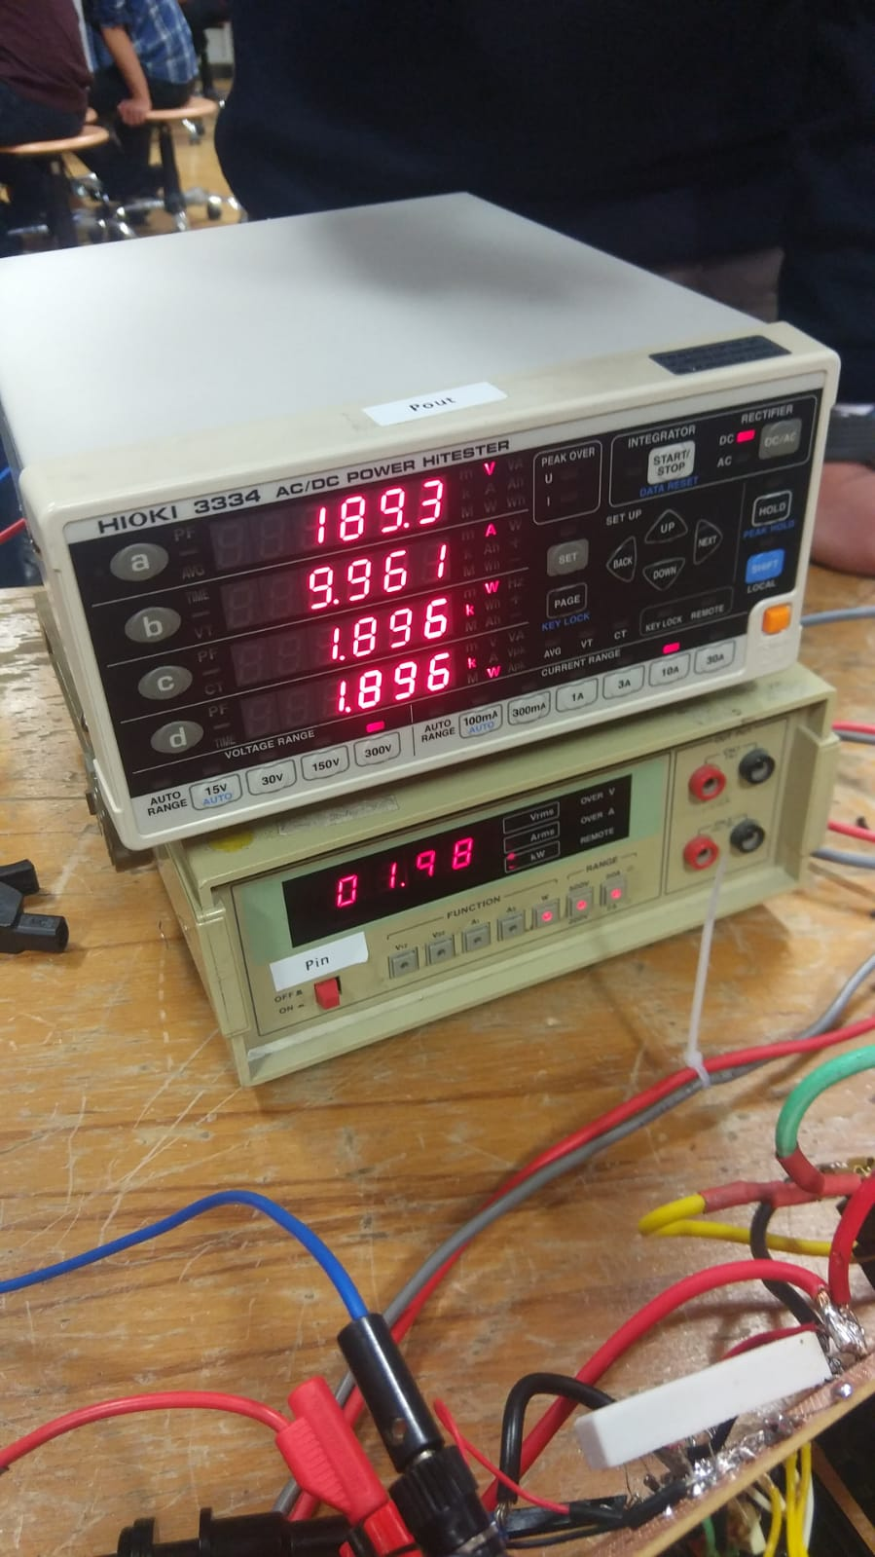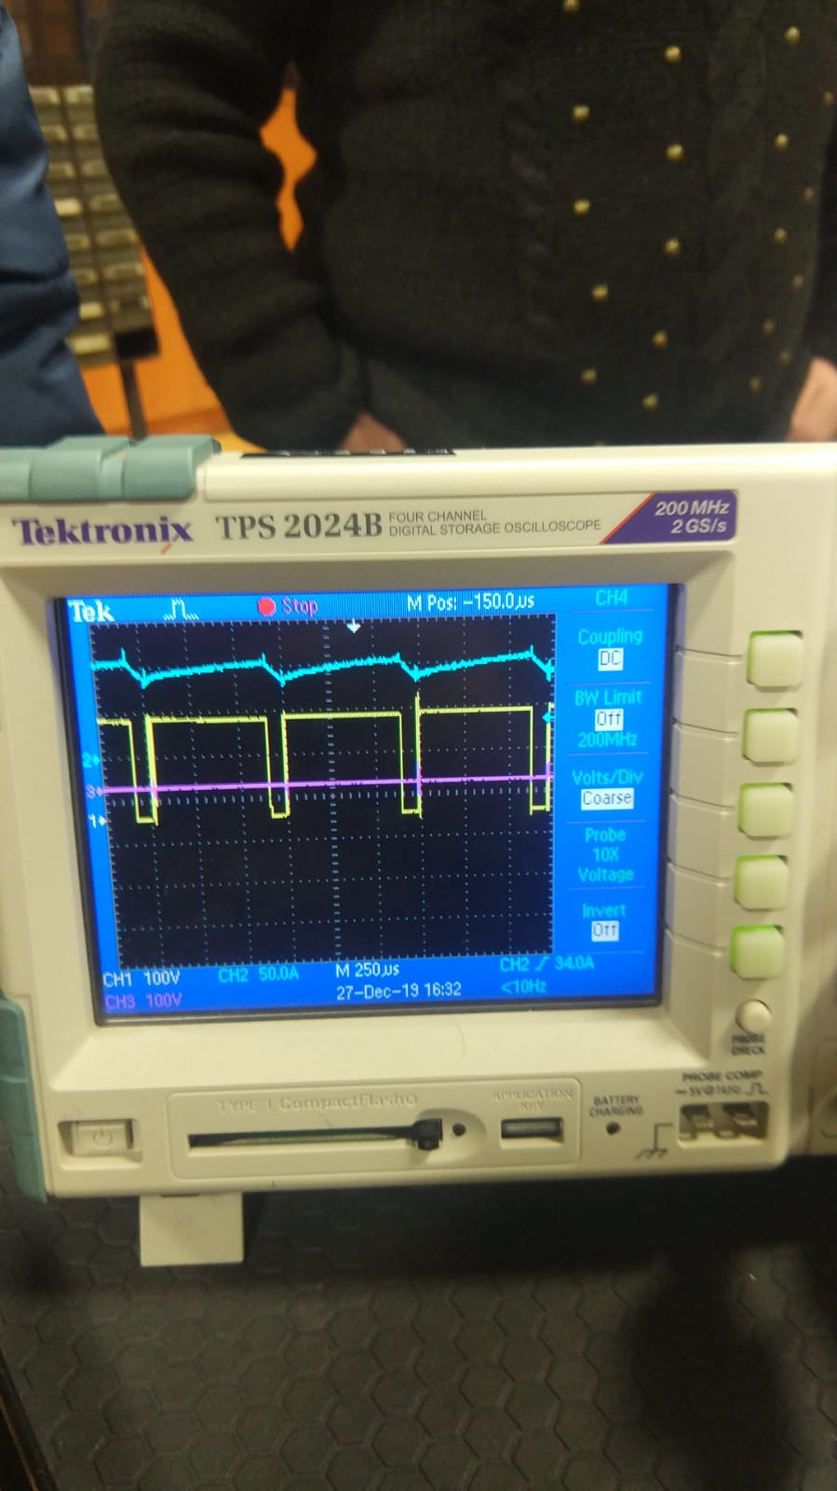

Figure 18 Kettle loaded test with duty cycle=90% and output voltage=189.3V

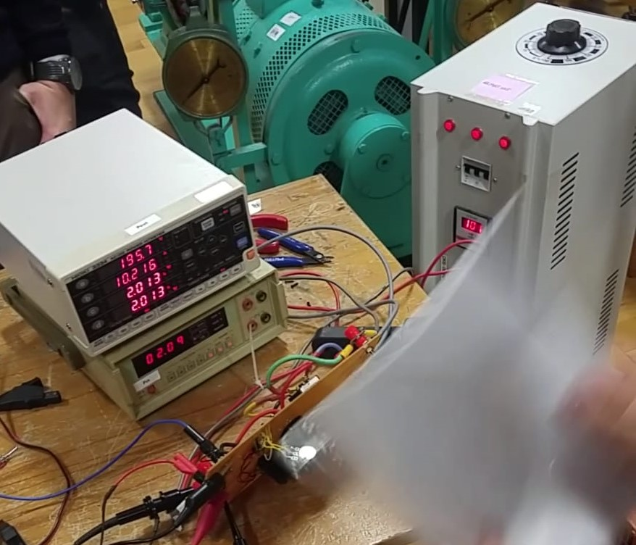

Figure 19 Kettle loaded test with duty cycle=90% and output voltage=195.7V

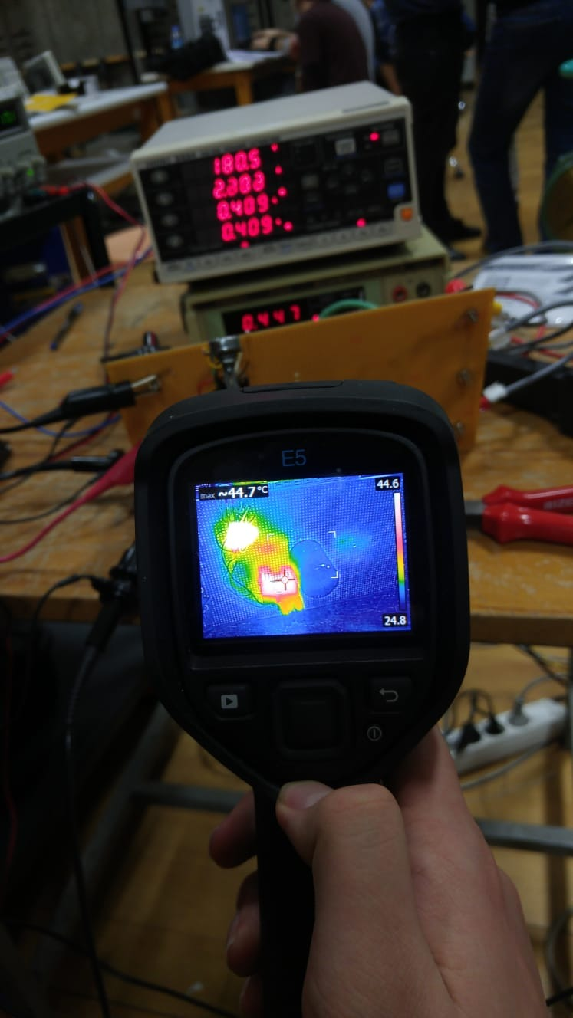

Figure 20 Thermal camera reading for 180v no load case

# 5. Cost Analysis

Although we used some of the components from the inventory, we included their prices in the cost analysis to make a better estimation of our final product’s cost. Note that, some of the components like optocoupler and IGBT burned down and we had to replace them. They are not included in the main cost analysis since they would not cost extra money considering our circuit as a prototype of a commercial product. Cost of each product and their total cost are given in the table below. Also, additional information about burned down components is given in Table 2.

Table 2: Cost Analysis of Components

|  |  |
| --- | --- |
| **Component** | **Cost** |
| 36MT160 Bridge Diode | 54.21 TL |
| 330 uF 400 V DC Link Capacitor | 11.10 TL |
| IXGH24N60C4D1 IGBT | 13.18 TL |
| DHG30I600PA Freewheeling Diode | 12.84 TL |
| TL494 PWM Controller | 1.46 TL |
| TLP250 Optocoupler | 8.67 TL |
| 7x 4mm Connector | 9.73 TL |
| 13 x 25 mm Stripper | 13.53 TL |
| 50 cc Thermal Paste | 18.73 TL |
| **TOTAL** | **143.45 TL** |

As summation of components given above, we found our total cost as 143.45 TL. Note that, some components such as resistances and capacitances that are used in PWM circuitry are excluded in this analysis, since their prices are negligibly small with respect to components that are given above in the table. We can round this value up to 145 TL, including neglected prices.

In addition to components that were used in the final working prototype, during implementation, we burned down 1 IGBT and 2 optocouplers, causing extra 30.52 TL cost. There were also some components that we bought as backups such as a capacitor, but we did not need to use them. As a result, they were not included in the cost analysis.

# Challenges

While we were moving from design of our project and simulations to implementation of the project, some extra issues that we needed to consider occurred. Firstly, we had a PWM signal in our design which was created using mathematical blocks of Simulink. In addition, there was another simulation file that was generating PWM signal using 555 Timer. However, it was not possible to connect 555 circuit’s output directly to transistor’s gate since the output current of 555 is not enough to charge and discharge transistor’s gate capacitance. To overcome this problem, we created our PWM signal with TL494 and we used TLP250 optocoupler. These choices were described in detail in Design Choices part.

Another challenge related to PWM signal was placement of gate driver. We wanted to keep this path as short as possible in order to keep inductance minimum. It would enable us to change current quicker, as PWM signal changes from positive to negative. However, it was not as easy as it we thought it was since we wanted to keep freewheeling diode to IGBT as well and we did not want their heat sink’s to touch each other for thermal and electrical isolation. As a result, we came up with an optimum layout of our design that operated very well, which can be seen in the Figure 21.

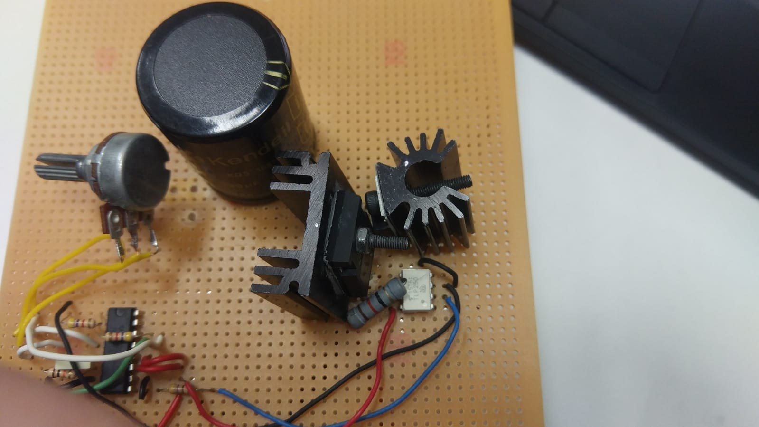

Figure 21 Optimized layout for semiconductors

Final issue that we had to deal with regarding PWM generation was related to optocoupler circuitry. Although it operated properly once the circuit is created, it failed after some time and IC burned down. This happened twice to us, which was problematic for robust operation. After some research, we found that placing a 10 nF capacitor between ground and IC is the solution to our problem.

When the circuit is de-energized, there was remaining energy stored energy in DC link capacitor. It could be problematic while we were still implementing the project since the capacitor could be discharged from some unwanted path due to contacts. To solve this, we considered adding a stone resistor in parallel with the capacitor. It worked well in terms of discharging but caused another problem in terms of heating. It was creating excessive heating, especially during AC machine was feeding kettle. In long operations, it could have risen component temperatures above rated values. Consequently, we disconnected stone resistor which caused slower discharge of capacitor in return of better thermal design.

# Conclusion

In this report, detailed information about EE463 course’s hardware project is given. The process started from the topology selection, and the system is built based on 3-Phase Rectifier + Buck Converter topology. Necessary components are purchased/supplied from the laboratory. The building and testing phases of the system is carried on. Lastly, at the demo day, the circuit is first tested at 400W with unloaded motor. Then, for robust design bonus, motor is loaded with a kettle and run again. Our system has performed successfully during the demonstration and our design choices are proven to be working.

Also, how the design choices are made, how certain parts of the circuits is built and the challenges that we faced during the whole project is explained in detail. Cost analysis of the project is done. Simulation and test results are tabulated.

Since the project covered critical parts of the course, it required us to use some new skills we have gained throughout the semester. This helped us solidify our knowledge. Moreover, building a real-life system using real components introduced us to the challenges we have not faced before. Identifying and resolving such challenges was a significant experience since our point of view is broadened about the topic.